**Root Length**

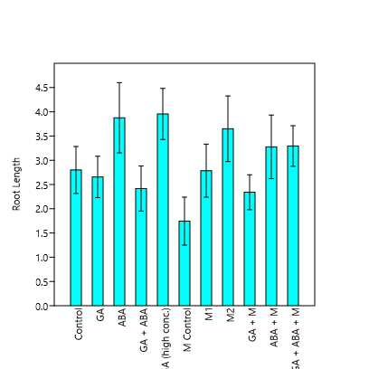

Root Length Bar plot with 95% confidence interval

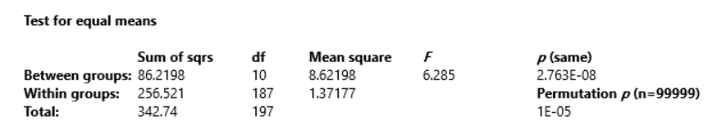

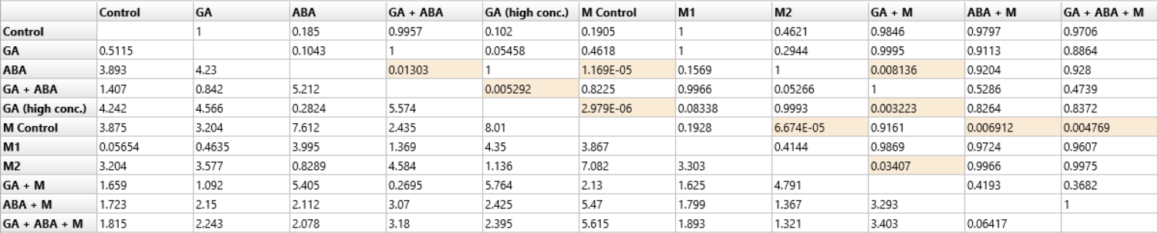

**Shoot Length**

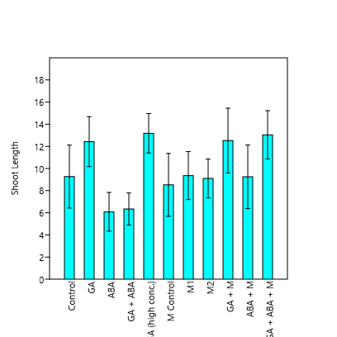

Shoot Length Bar plot with 95% confidence interval

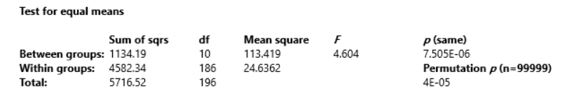

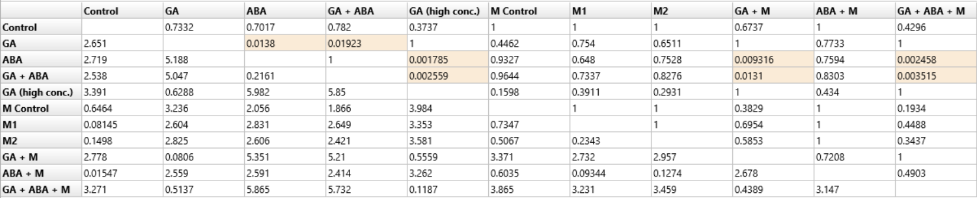

**Shoot/Root Length Ratio**

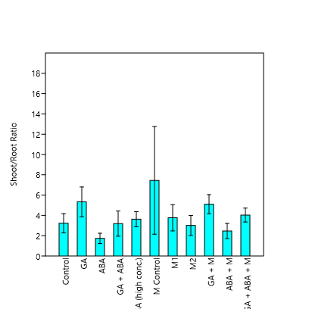

Shoot/Root Length Ratio Bar plot with 95% confidence interval

